Kevin’s Question
We had a question on Friday from Kevin asking if he has a customer looking for 3 ton valve and the only options are a 2 ton and a 4 ton valve which one should he select? I said that a balanced port would be better over a conventional valve during the training and that is not always correct. My mistake. Using the Emerson TXV selection the software will select the best option for your input parameters. https://webapps.emerson.com/wrproductselector/flowcontrols.aspx If you are doing it out of the catalogue you would have to go to the extended capacity charts, look at the nominal value, verify the evaporator temp and look at the pressure drop (Table 1) and look it up that way because there is no simple answer.
Link to the TXV Extended Capacity Tables out of the flow catalog:
https://climate.emerson.com/en-us/products/heating-and-air-conditioning/air-conditioning-controls/flow-controls-catalog
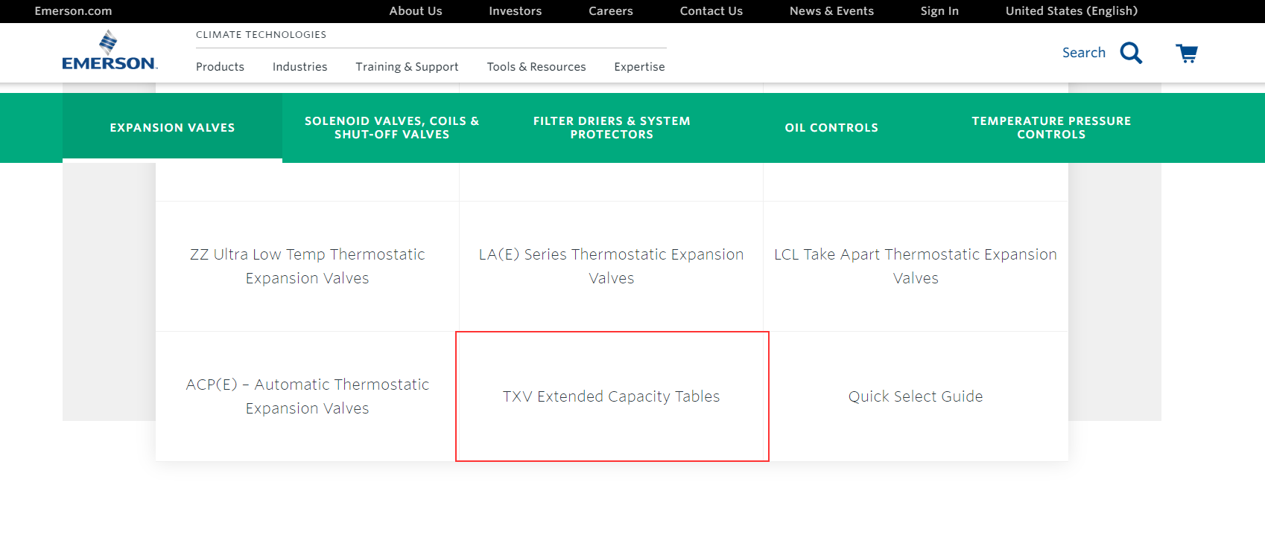
How to determine Net Pressure Drop: 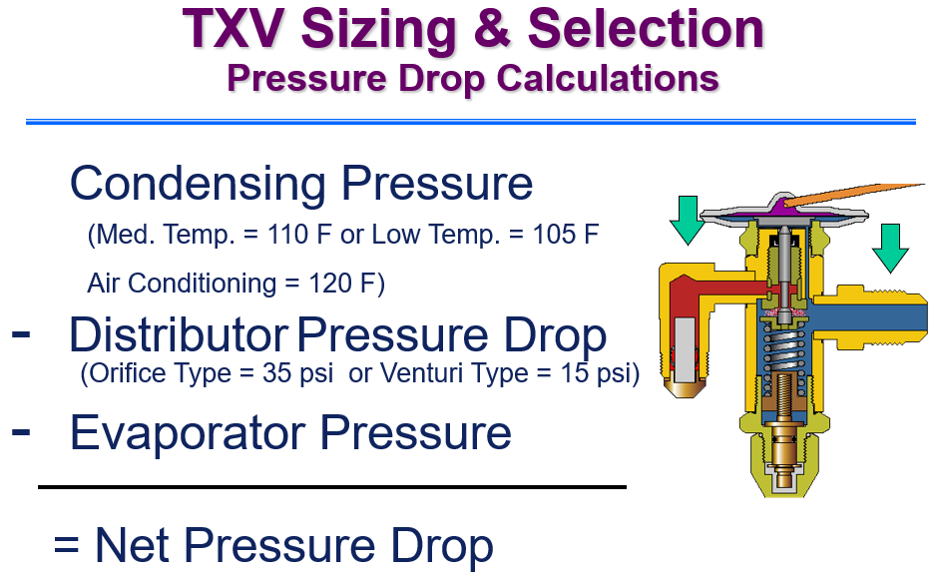
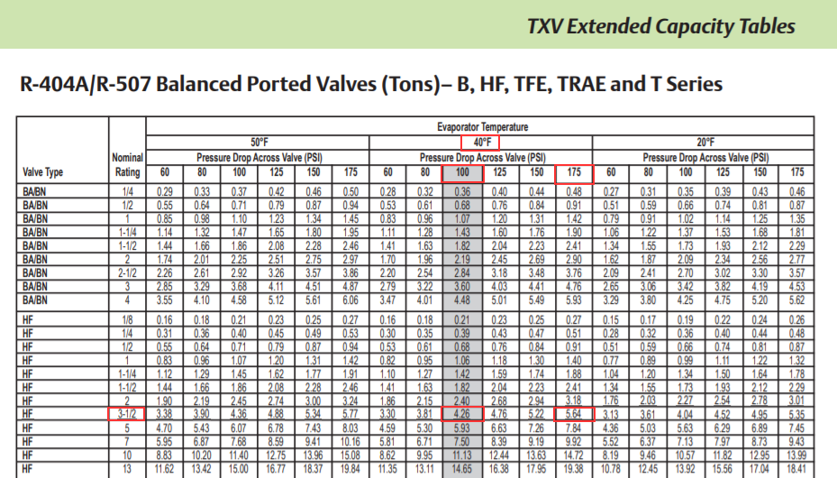
Table 1
So, for example above a R-404 HF 3 ½ ton nominal rating valve at 40F evaporator temperature at 100 psi pressure drop across the valve (industry standard rating) is really a 4.26 Ton valve. You have to understand what the potential pressure drop across the valve and all your condition before selecting the valve because using all the same conditions with a 175 psi pressure drop the same valve is a 5.64 Ton valve which may be oversized. You may have to look at a different valve.

Kevin’s Example:
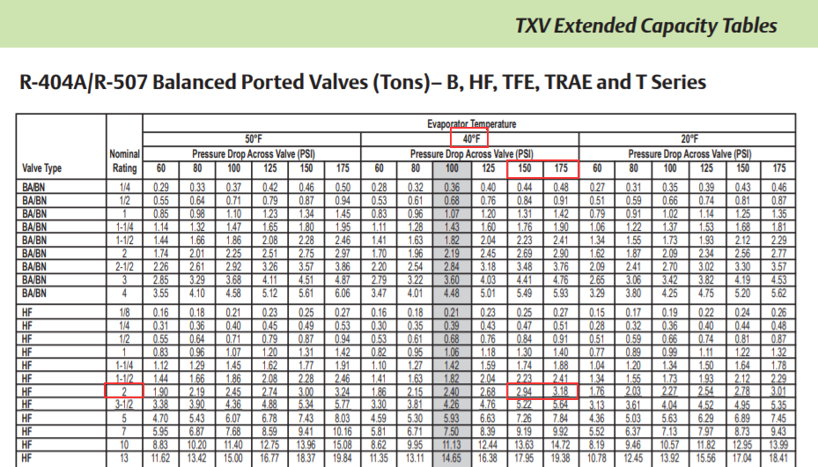
An if Kevin’s was looking for an HF - R-404a 3 ton valve with a Evaporator Temperature at 40F, the pressure drop across the valve would need to be around 150 to 175F to get in the range of a 3 ton valve but the nominal capacity rating is 2 ton.

